Hello.How can I insert a color code # CC0000?
In the setting of the selected item in a row to insert the code - is inserted only 6 characters.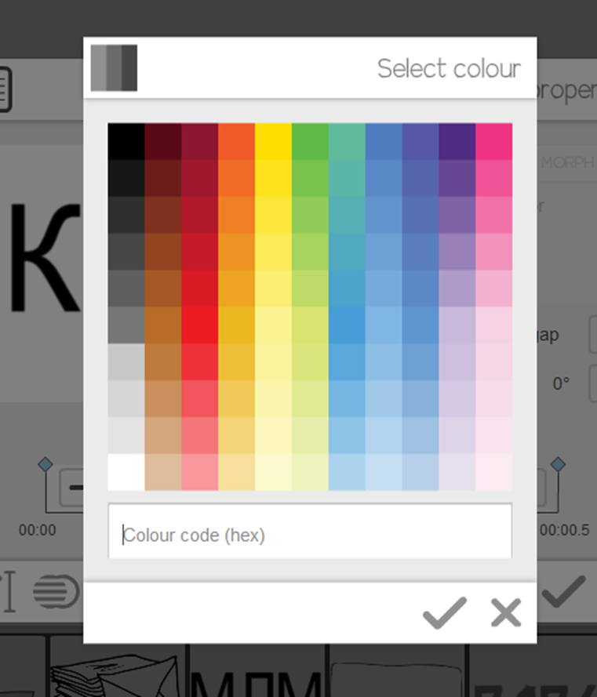
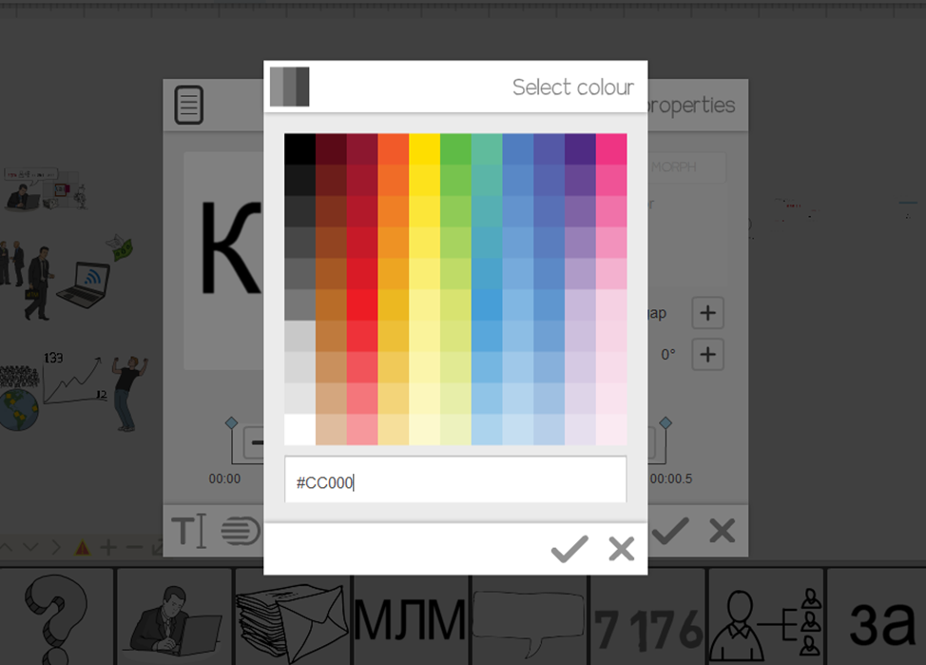
The proposed list of desired colors Sparkol I do not.
Please, extend the program the ability to add color code.
I'm using version VideoScribe version 2.2
Thank you.

