STORY BOARD -- Repeal Transportation Bill

Title: YIELD 2 REPEAL
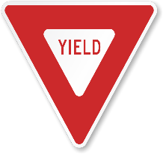

Music – “Keep on Pushing” background music during entire video https://www.youtube.com/watch?v=Hh7ANTOQ2Rs
(sound track = 2:30 – fade out at 15 seconds of sound track)
$500M WIN for urban areas
- Baltimore
- Montgomery
- List more
LOSS for rural areas
Wipe: fade in each county sign

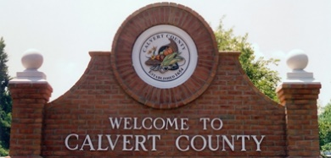
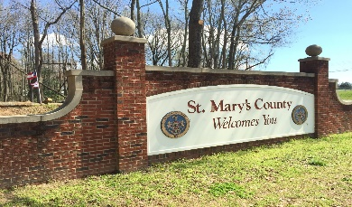
No Funding
- Johnson Bridge
- Route 235 St. Mary’s
Tax transfer – Rural to Urban
- We all pay but rural areas get zero
- Push for all counties to collect/keep local gas tax

Fade music “Keep on Pushing”

