Gandhi- The Charismatic Leader

Namaskar and a very good morning children.
दे दी हमें आज़ादी बिना खड्ग बिना ढाल
साबरमती के सन्त तूने कर दिया कमाल
आँधी में भी जलती रही गाँधी तेरी मशाल
साबरमती के सन्त तूने कर दिया कमाल
दे दी ...

De di hame azadi bina khadag bina dhal, Sabarmati ke sant tune kar diya kamaal

So children, when we hear this song the first thought which comes to our mind is of a leader who got us freedom by his novel method of Non Violence or Ahimsa. It was the first time in the history of the world that the Britishers who ruled over almost the entire world were defeated in India by this great man Mohandas Karamchand Gandhi by his non- violent struggle.

This charismatic leader led the nation from the front and made us achieve the seemingly impossible dream of independence on 15 Aug 1947.

Children, it is therefore very important that before we study about our Freedom movement we must first learn about this great man who led us to freedom.

Let me narrate to you a story of little Mohan to bapu Gandhi

https://youtu.be/35Dws72mHeU----story of gandhi

Let me narrate to you a story of little Mohan to bapu Gandhi

Mohandas Karamchand Gandhi was born on this day, October 2, in the year 1869. The birth anniversary of the Father of the Nation is celebrated, all over India, as Gandhi Jayanti. His selfless contribution to the freedom of India earned him the name of Mahatma Gandhi.

“Long ago, 150 years back on 2nd October1869, a cute little baby was born in Porbandar town in Gujarat. Father Karamchand Gandhi and mother Putlibai were very happy. They named the baby “Mohan” — Mohandas Karamchand Gandhi. When Mohan grew, he was greatly influenced by honesty and strict discipline of his father and by simplicity and religious thoughts of his mother. At very early age, the shy little child learned great values of truthfulness, integrity, honesty and discipline. He lived these values throughout his life and rightly demonstrated power of these values to entire world.
When Mohan grew older, like any other teenagers, he also fell in bad company and picked up few bad habits as well. He hid these bad deeds from his parents. But his values did not allow these bad habits to linger any longer with him. He realized the mistake and sincerely repented for his bad habits. He confessed to his father by writing a letter to him. Perhaps this incident made him to devotedly, throughout his life, obey the values taught by parents.
Mohan was sent to England to study law. After study, he became lawyer in India. For a case, he visited South Africa. Those days there was discrimination between white and color people. He was ill-treated by a British who threw him out of first class compartment of a train. It was very humiliating experience. He decided to fight against this inhuman color discrimination by British and came back to India.
Unlike any other contemporary violent protestors, Mohan created a new method to fight against British — Satyagrah: protesting injustice in a nonviolent way. Very soon, many people started following him. People called him Bapu (the father) and Mahatma (the saint). Bapu and his followers non-violently galvanized whole India against British rule. British arrested Bapu and his followers and sent them to jail many occasions but it did not deter the sathyagrahis’ will to fight against injustice. There was no discrimination in Satyagraha — people with all religions and all castes joined Bapu. Everyone, be it Muslim or Hindu or Sikh or from any other religion, accepted other in Satyagrah as own brother or sister.
Finally British understood that it would not be possible to rule India against Bapu and his followers. Our country got independence on August 15, 1947. It was first time in history of world and mankind that a huge victory was achieved by Satyagrahs, by nonviolence.
Since then whole world has recognized greatness of Bapu and might of his novel method Satyagrah (nonviolent protest). Many other famous leaders throughout the World such as Martin Luther King, Aung San Suu Kyi, Nelson Mandela, Anna Hazare etc followed Satyagrah and nonviolent method to protest against injustice or to achieve agreement with ruling government. I shall tell you story of these superheroes in coming days. For now let’s pay our sincere homage to our respected Bapu by pledging to follow values he lived.

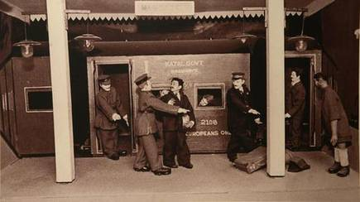

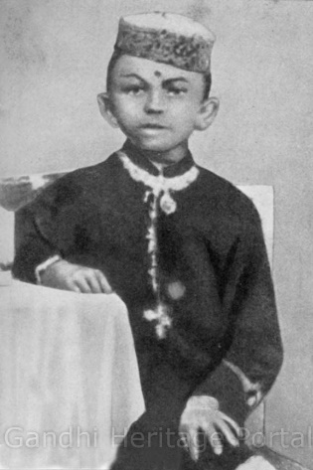

There was a boy. His name was Mohan.
He was studying in a school at Rajkot. He was not bright at studies, but was very fond of reading.
Once he read the story of Shravana. Shravana used to carry his old and blind parents in two baskets slung on a bamboo yoke. Mohan was deeply touched by his devotion to his old parents. He resolved to be like Shravana and serve his parents.
Once Mohan saw a play depicting the life of King Harishchandra, who lost his kingdom and suffered much for truth. Mohan was so deeply moved by this play that he was in tears. He decided never to swerve from the path of truth and be ever truthful and honest like Harishchandra.
In his childhood the young Gandhi was very timid. He feared to step in darkness, even in his own house. He feared ghosts and thieves and snakes. Rambha was a maid servant in his house. Once she said to Mohan: `Why are you so much fearful? Remember Rama! Rama will always protect you. Fear never encounters him who remembers Rama.'
Mohan was deeply impressed by these words. He took to reciting the name of Rama. His faith in Rama increased as he grew up. He remembered God and dedicated all his work to him. When he died his last words were `He Rama!'

So many changes comes in your life

- Anything is possible – Mahatma Gandhi was not born in a family of great leaders nor was he a child prodigy or a genius like many other famous people. He was a common man who used to be very shy in childhood. He still emerged as a leader and a great man. The lesson you can learn is to believe in yourself and do what feels right. Never think any less of yourself.
- Keep trying – He never stopped trying until he succeeded. Step by step and slowly, he achieved what he wanted. We can learn the lesson of trying till we succeed. Success comes slowly to those who try and not to those who lose patience and stop trying.
- Non-violence – Mahatma Gandhi always followed the path of non-violence and achieved what he wanted through peace. Sometimes, things around us make us sad and upset. But we can learn from him the lesson to stay calm in the tough situations. Try to follow the path of peace instead of violence to handle the tough situations.
- Simplicity – You don’t need materialistic things to be happy. Gandhi Ji was a very simple man. He was happy and positive in whatever he had and never lived a fancy life. Money and materialistic things don’t matter if you are not happy. Simple living and high thinking was his mantra.
- Be a role model – Gandhiji’s famous quote- ‘Be the change you want to see in others’ teaches us to be a role model and to lead by example. He was an active participant in all his campaigns, whether it was Dandi march, satyagraha or quit India movement, he was a role model. So, its always better to change yourself first and then expect the world to change.
- See no evil, hear no evil and speak no evil – We all heard of this lesson when we were small. Gandhiji’s 3 monkeys are every famous who teach us this lesson.
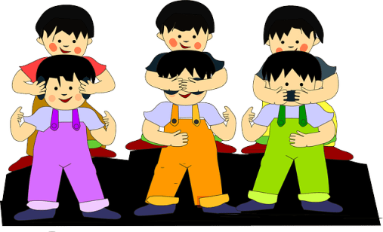

We often complain about so many things which we see around. But if we look at Mahatma Gandhi’s life, we get to learn many important lessons which can be useful for us. Our kids can definitely learn some lessons of truth, nonviolence, and leadership qualities from him and his life.
Mahatma Gandhi’s life is very inspiring. What inspires you? Share the things which you think we can teach our kids.

